Room Request Form (External)

REQUESTED EVENT DETAILS
Event Title: Click or tap here to enter text.
Event Date Requested: Click or tap to enter a date. | Expected Attendance: Click or tap here to enter text.
Start Time: Click or tap here to enter text. | End Time: Click or tap here to enter text.
Room Preference? Click or tap here to enter text. | Type of Event: Choose an item.
Number of Rooms Needed: Click to enter

REQUESTORS CONTACT INFORMATION
Requested By: Click here to enter text. | Telephone Number: Click to enter number
Mailing Address: Click here to enter text.
Email Address: Click here to enter text. | Organization: Click here to enter text.
Brief Description of event: Enter text here.

INSTRUCTOR/FACILITATOR EQUIPMENT NEEDS
☐ Projector |  | ☐ Registration table needed? Quantity? Enter quantity.
☐ Easel
☐ Microphone (Auditorium only)
☐ Trainer Supply Kit Items Included

ROOM RATES
Classrooms (Weekdays) | Auditorium (Weekdays) | Computer Lab (Weekdays) | Atrium (Weekdays)
$500 | $600 | $600 | $400
Classrooms (Weekends) | Auditorium (Weekends) | Computer Lab (Weekends) | Atrium (Weekends)
$700 | $900 | $750 | $500

Time Overage: $15/half-hour Make Ready/Cleanup: $50

ACKNOWLEDGEMENT
By signing this request form, I have verified that all details of the reservation are correct. I acknowledge that I have read, understand, and agree with the City of Houston, Office of Talent and Organizational Development Division terms of training/conference room usage.

Type Name to Sign: Click to sign.

Today’s Date: Click a date

We appreciate your interest in utilizing the facilities at the E.B. Cape Center for your upcoming event. To ensure a smooth reservation process, kindly adhere to the following guidelines:

- Request for rooms must be submitted at least (5) business days in advance using the attached form via email to OTODRooms@houstontx.gov.
- Following your request, our team will promptly respond within two (2) business days via email to confirm the availability of the requested room.
- Upon approval, confirmed reservations will be updated on the OT&OD Rooms calendar. You will receive an email notification once the reservation is finalized.
- Cancellations should be communicated at least one week prior to the scheduled event. This allows us to accommodate other requests efficiently.
- If you plan to conduct a presentation, kindly bring your laptop. Ensure compatibility with our facilities for a seamless experience. Please have all your handouts, printed materials, or books made for event(s) and training classes. All rooms have a standard setup. If a different setup is needed, you will be responsible for rearranging & replacing to original setup.
- All rooms must be restored to their original configuration after use. Please handle all equipment with care and return it to its original location upon completion of your event.
- For questions or concerns, feel free to reach out to the OT&OD Administrative Assistant at (832) 395-4827 or via email at OTODRooms@houstontx.gov.

Supplementary Information:
- Organizations or individuals intentionally misrepresenting their employment, organization, or the nature of the scheduled event will forfeit existing space reservations. Furthermore, they will be barred from scheduling future activities at the E.B. Cape Center facilities.

Please scan and email Pages 1 and 2 to OTODRooms@houstontx.gov

Thank you!

Room Reservation Agreement and Procedures

Please carefully review the following agreement and guidelines for your upcoming event. The OT&OD provides classrooms, furnishings, and equipment. A designated liaison will coordinate the room, equipment, and any special services as indicated on this Room Request Form. Please note that food of any kind is strictly prohibited in the Auditorium. However, a breakout room can be assigned for food services at an additional charge.

Upon request, the OT&OD will provide a “Trainer Supply Kit” to enhance your presentation experience. The kit can be checked out at the front desk in the lobby prior to your event. It is mandatory to return the supply kit to the front desk and check it back in once your event concludes. The contents of the supply kit include tape roll, tape dispenser, stapler, pack of staples, sticky notepads, paper clips, scissors, pack of pens, whiteboard eraser & markers (3pk), laser pointer/presenter, and HDMI cord. Please ensure the responsible use and timely return of the trainer supply kit to facilitate its availability for other events.
Reservations:
- Request for rooms must be submitted at least (5) business days in advance using the attached form via email to OTODRooms@houstontx.gov.
- Following your request, our team will promptly respond within two (2) business days via email to confirm the availability of the requested room.
- Upon approval, confirmed reservations will be updated on the OT&OD Rooms calendar. You will receive an email notification once the reservation is finalized.
- Cancellations should be communicated at least one week prior to the scheduled event. This allows us to accommodate other requests efficiently.
- If you plan to conduct a presentation, kindly bring your laptop. Ensure compatibility with our facilities for a seamless experience.
- All rooms must be restored to their original configuration after use. Please handle all equipment with care and return it to its original location upon completion of your event.
- For questions or concerns, feel free to reach out to the OT&OD Administrative Assistant at (832) 395-4827 or via email at OTODRooms@houstontx.gov.

Room Use:
- Activities scheduled must adhere to the allotted time provided in your reservation confirmation. OT&OD staff reserves the right to interrupt any meeting that exceeds the scheduled time to ensure availability for the next reservation.
- All rooms have a maximum capacity, in accordance with the City of Houston Fire Code. Room occupancy must not exceed the specified maximum capacity, and OT&OD staff will ensure compliance with code regulations.
- The individual making the room reservation is responsible for the condition of the room at the conclusion of your event. All rooms must be left in their original condition.
- Users are permitted to move and rearrange tables and chairs; however, furniture must be returned to its original position.
- Post-It easel pads and self-adhesive flip chart paper may be attached to the walls. However, the use of all other types of adhesives is strictly prohibited.

Room Use (cont’d):
- The user is responsible for leaving the room in good order and is financially liable for any damage to or loss of City of Houston property.
- Users must ensure that scheduled meetings or activities do not disturb other building occupants, interfere with work-related activities, or disrupt the ongoing conduct of city business. Authorized OT&OD staff may intervene to stop activities that do not adhere to these guidelines.
- Food and non-alcoholic beverages are allowed in the meeting rooms. Users are responsible for providing all refreshments, including coffee and condiments. The room must be cleaned, and all trash must be discarded at the end of the event. Trash receptacles are provided in all rooms, and leftover food should be placed in the large bins located in the hallways.

Equipment:
- At the conclusion of your event, please ensure that the projector, power supply cords, and lights are turned off. When powering down the computer equipment, it is essential to do so correctly. Avoid turning off the computer by pressing the main power button, as this may result in damage to the equipment.
- The whiteboard should be cleaned of all marks. Only utilize markers and erasers specifically designated for the whiteboard. Please refrain from using permanent markers, as they can cause damage to the boards.

Regular Business Hours:
- Monday through Friday, 7:00 am – 5:00 pm
- If your event extends beyond regular business hours, please make arrangements in advance with OT&OD Administrative Assistant at (832) 395-4827 or OTODRooms@houstontx.gov.

Prohibited:
- Users are strictly prohibited from attaching anything to the walls, ceiling, windows, blinds, or any other fixtures within the E.B. Cape Center.
- The E.B. Cape Center strictly adheres to a drug, alcohol, and smoke-free policy. Smoking is prohibited within 20 feet of any building entrance, in accordance with the City of Houston code.
- The City of Houston prohibits the entry of any person carrying a firearm or other weapon, except for authorized security personnel and law enforcement officials.

Damages:
- Users may be held responsible for any damage caused to the facility, including furniture, audio/visual equipment, walls, doors, fixtures, and flooring. Any damage must be promptly reported to OT&OD staff.
- Groups, organizations, or individuals using the E. B. Cape Center facilities may be held responsible for the actions of participants attending their functions.
- Neither OT&OD nor the City of Houston assumes responsibility for any personal injuries, property loss, or damage that may occur while using the facility.

E. B. Cape Center – Room Views & Seating Capacity
1ST Floor
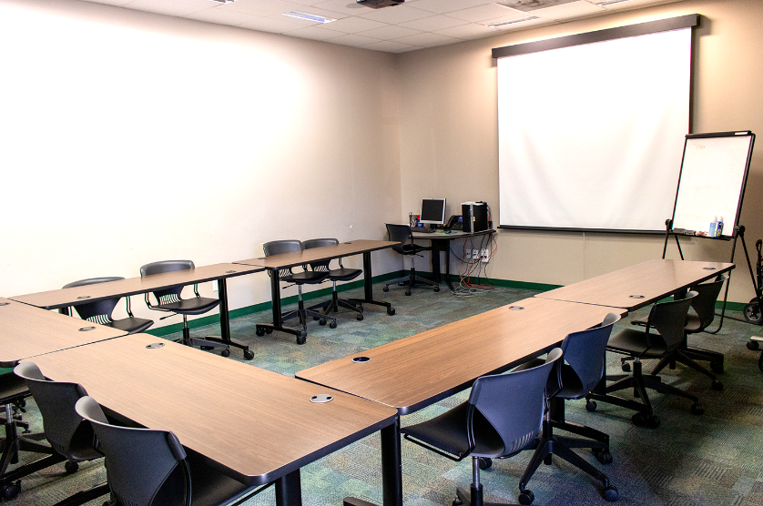 | Classroom 135  Capacity – 12  - Includes: Overhead projector/screen  - Computer  - Easel
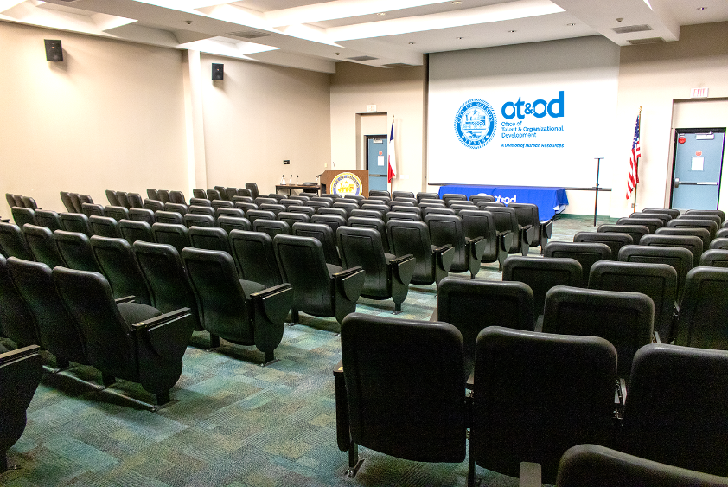 | Auditorium 107  Capacity – 150  - Includes: Overhead projector/screen  - 3 Microphones  - HDMI cord
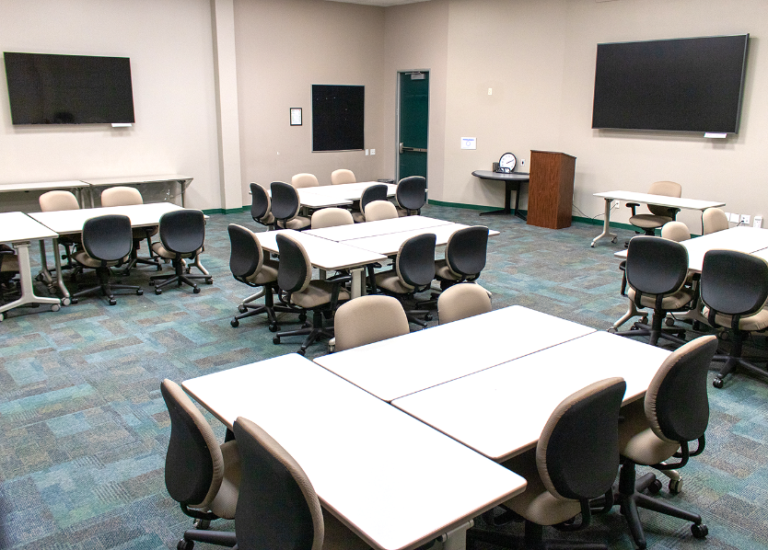 | Classroom 131  Capacity – 45  - Includes: 2 Flat Screen TVs  - Whiteboard
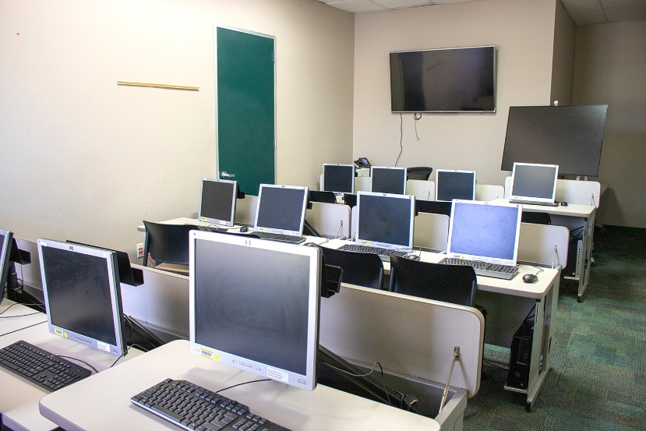 | Computer Room 129  Capacity – 10  - Includes: Flat Screen TV  - Whiteboard
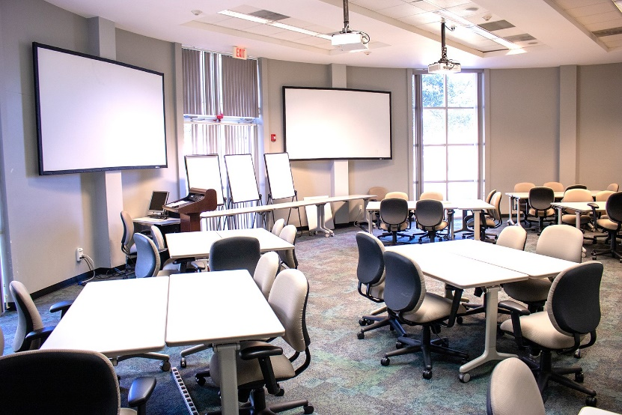 | Classroom 120  Capacity – 35  - Includes: Qty. 2 Overhead projectors/screens  - Qty. 3 Easels  - Whiteboard
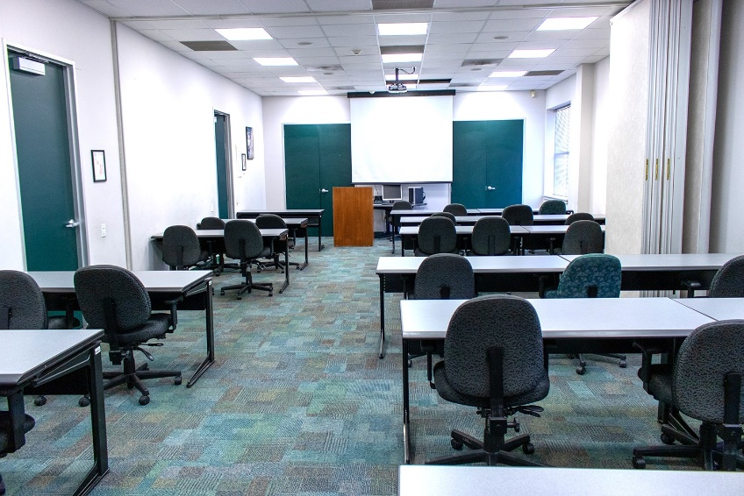 | Classroom 111/112  Capacity – 35  - Includes: Overhead projector/screen  - Computer  - Easel  - Phone  - HDMI cord

2nd Floor
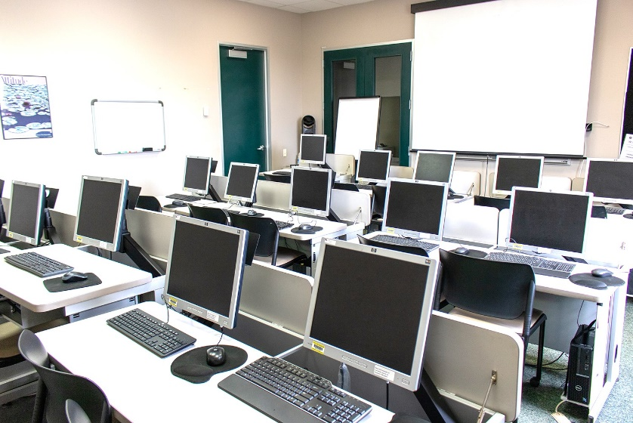 | Computer Room 215  Capacity – 14  - Includes: Overhead projector/screen  - 14 Computers  - Whiteboard  - Phone  - Printer  - Easel
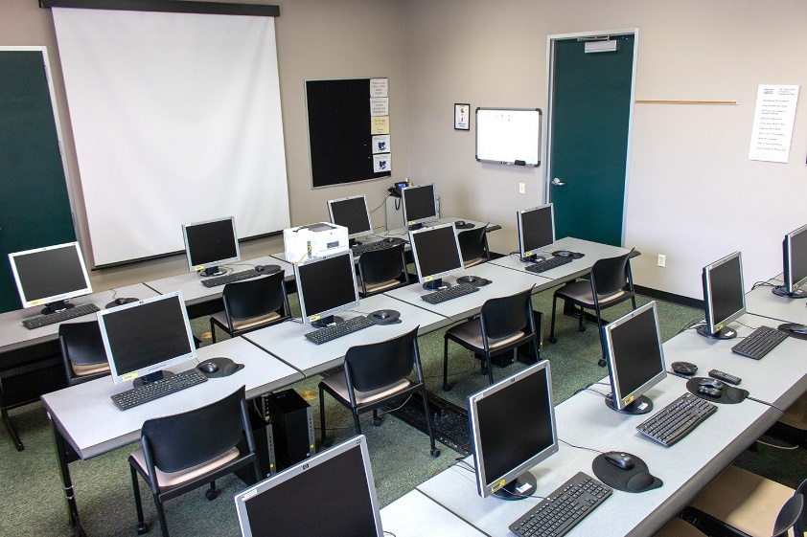 | Computer Room 216  Capacity – 12  - Includes: Overhead projector/screen  - 12 Computers  - Whiteboard  - Phone
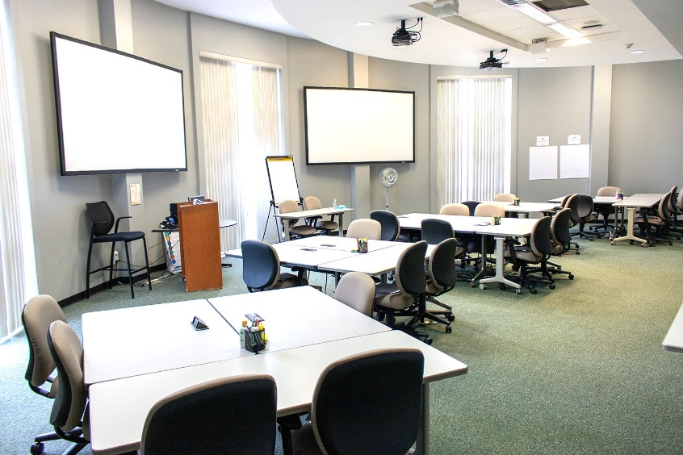 | Classroom 222  Capacity – 35  - Includes: Qty. 2 Overhead projectors/screens  - Whiteboard  - Phone
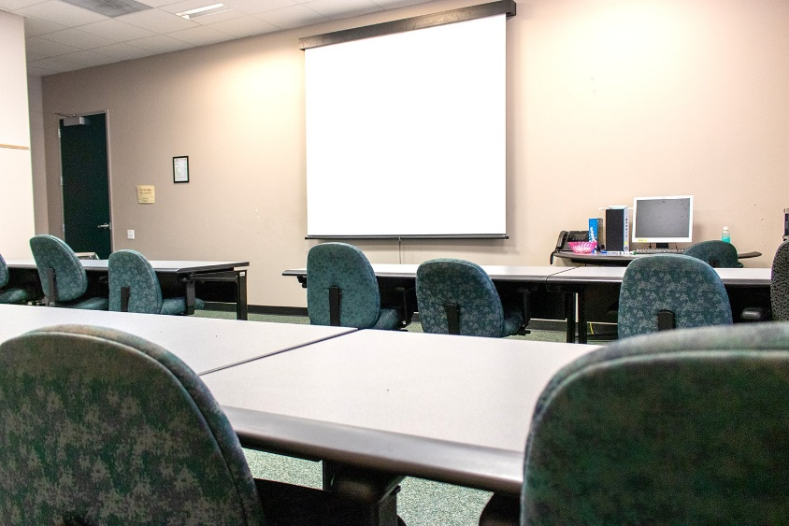 | Classroom 232  Capacity – 12  - Includes: Overhead projector/screen  - Computer  - Phone
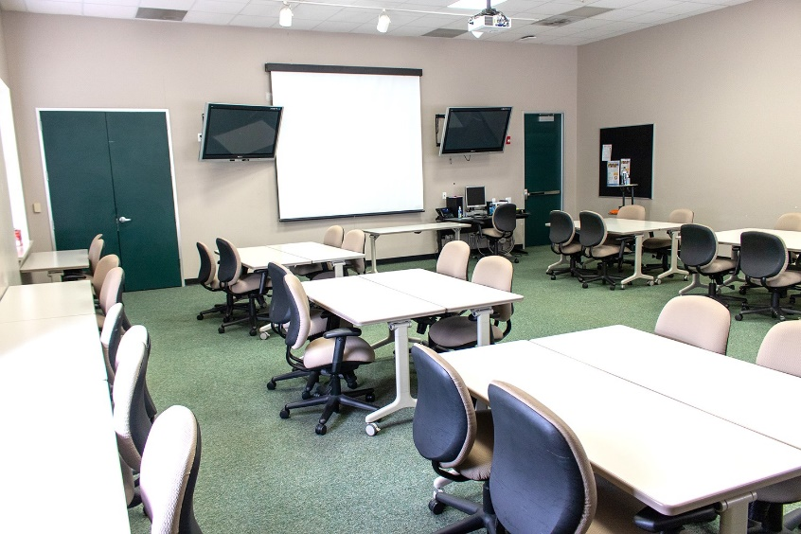 | Classroom 234  Capacity – 45  - Includes: Overhead projector/screen  - Computer  - Qty 2 Flat Screen TVs  - Phone

If you have any questions, concerns, comments, or need further assistance, please refer to the Office of Talent and Organizational Development website or OTODRooms@houstontx.gov for additional information.
Thank You!

